
PIEDMONT OPPORTUNITY CORRIDOR

has approved a
$100,000

GO Virginia Grant
for
Innovation Corridor Strategic Roadmap

The applicant


In collaboration with

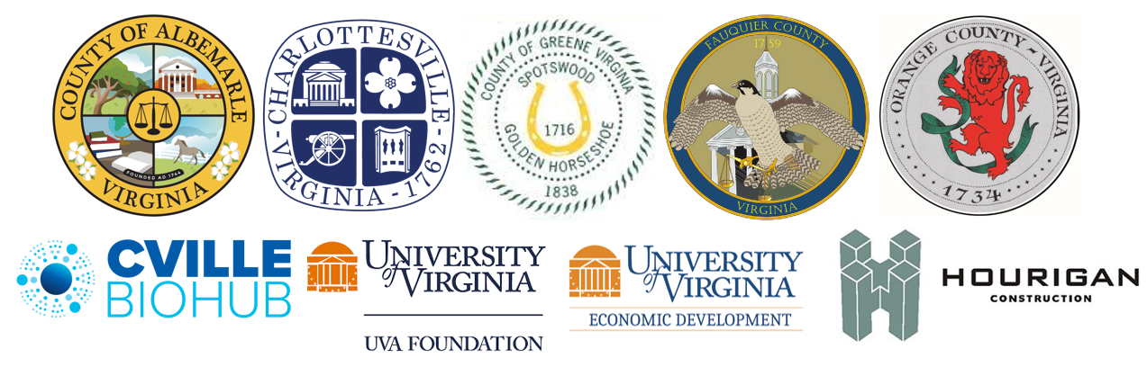
will use the funds to identify the region’s global strategic advantage based on an evaluation of assets across the GO Virginia Region 9 footprint to determine strategic priorities and specific actions for regional growth and industry cluster development.

GO Virginia is an economic development initiative to create high paying jobs and grow the traded sector through strategic regional collaboration.

Chair | GO Virginia Region 9 | Director
Ethan A. Dunstan | Central Virginia Partnership for Economic Development | Shannon Holland
 | 1001 Research Park Boulevard, Suite 301 | (434) 979-5610
 | Charlottesville, VA 22911 | ext. 103
 | www.GOVirginia9.org

